[Recover Key Pair and Windows 2008 R2 Instance Password on Amazon Web Services](http://sanketdangi.com/post/45978218303/recover-windows-2008r2-password-on-aws" \o "Recover Windows 2008 R2 Instance Password on Amazon Web Services)

This document explains how to recover the Windows instance password, when you lost your current password and unable to access your windows instance.

Step 1 : Create an image of the original instance (Which is not accessible).

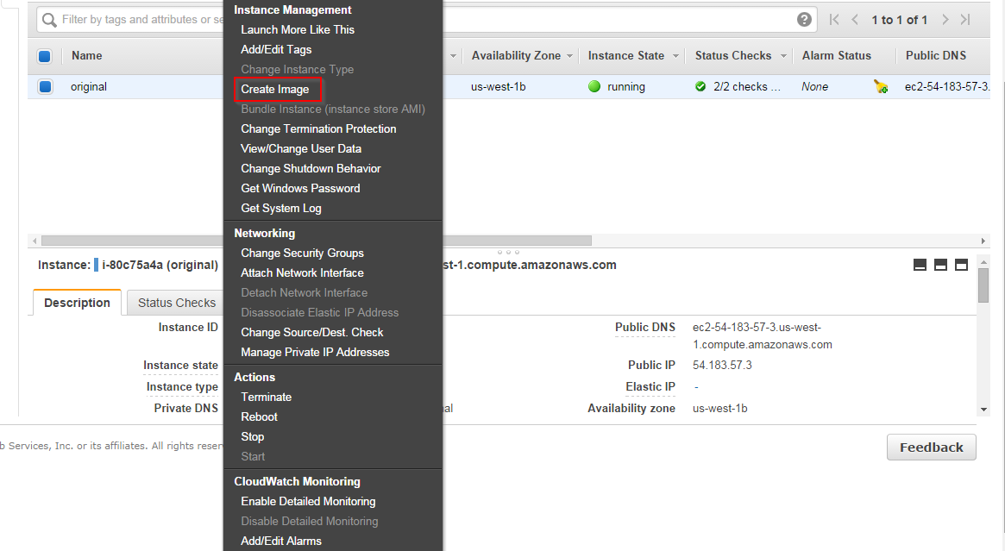

Step 2 : Give a name for the image and **click** on **create image** button.

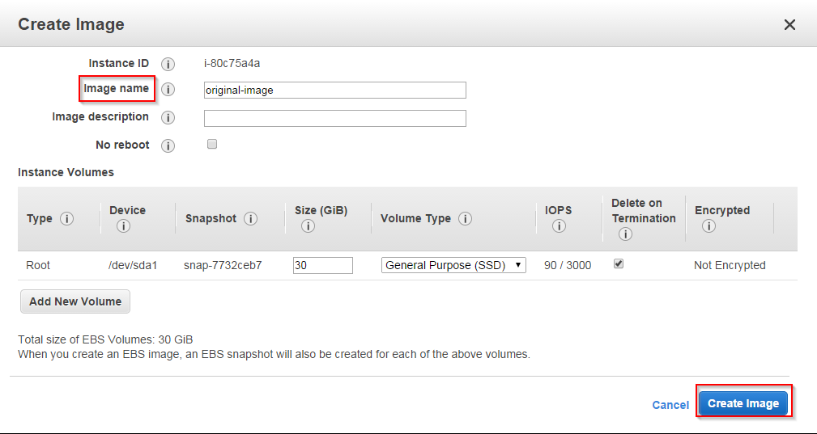

Step 3 : On next screen click on **close** button.

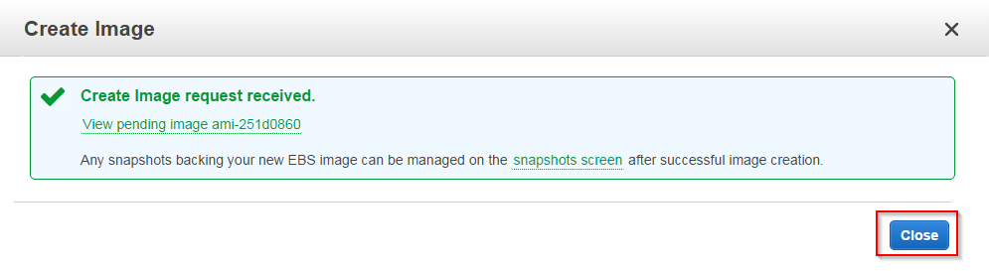

Step 4 : Go to AMI’s on the left panel to see the new image.

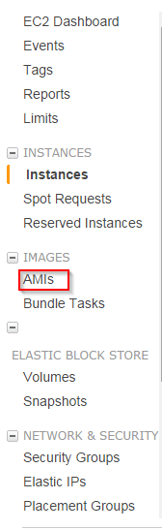

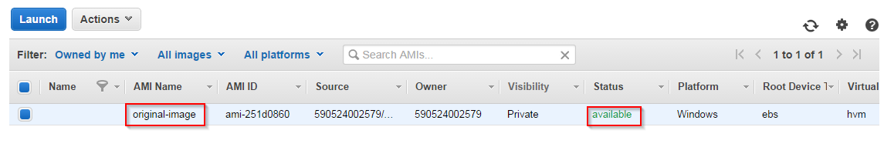

(Note: If the image status is available then the image is created and it’s ready for launch a new instance.)

Step 5 : click on **Launch** button to create a new instance.

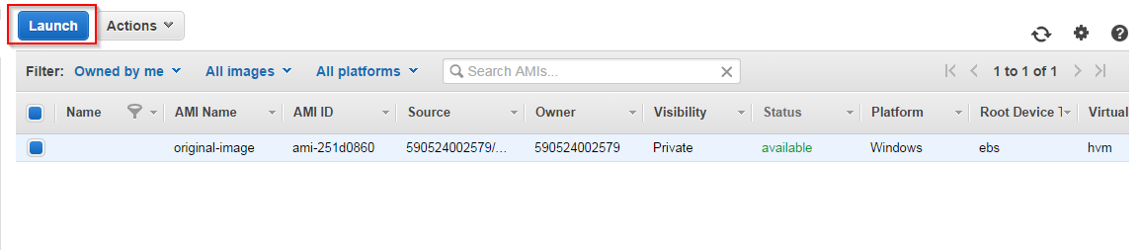

Step 6 : Select your instance type and click on **configure instance details** button.

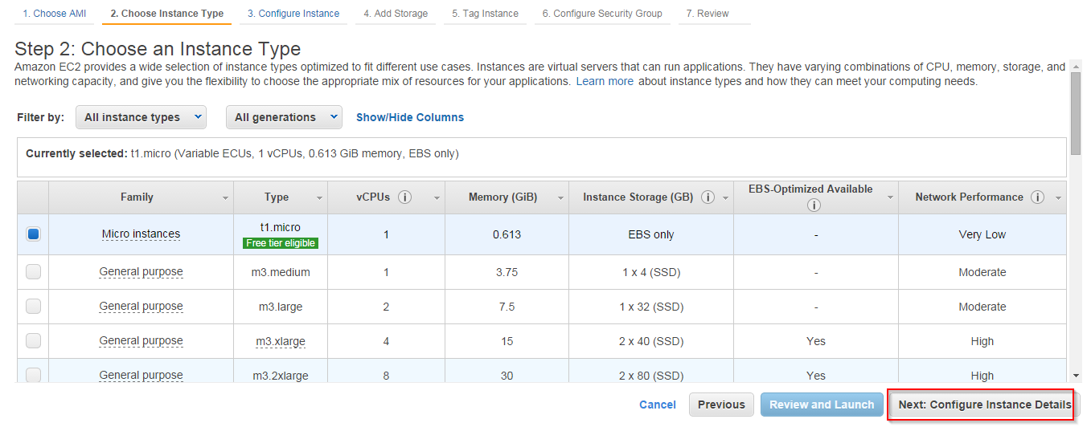

Step 7 : Click on  **Add Storage** button.

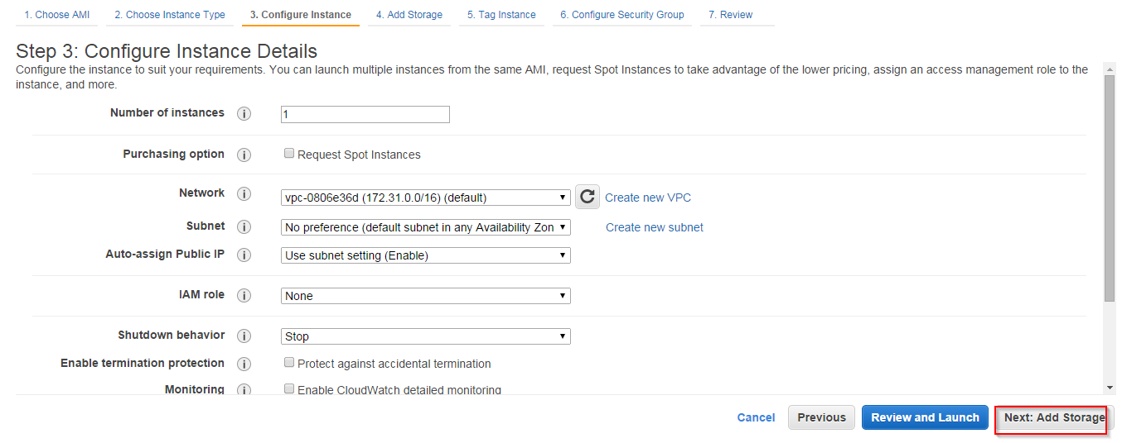

Step 8 : Click on **Tag Instance** button.

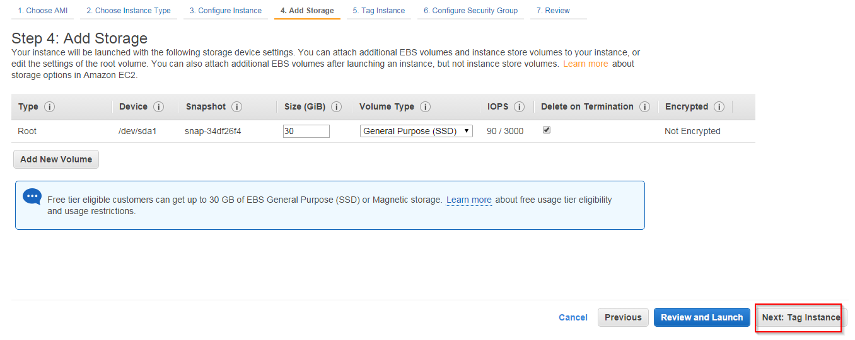

Step 9 : Give a name(ex: image-instance) to the instance and click on **configure security groups** button.

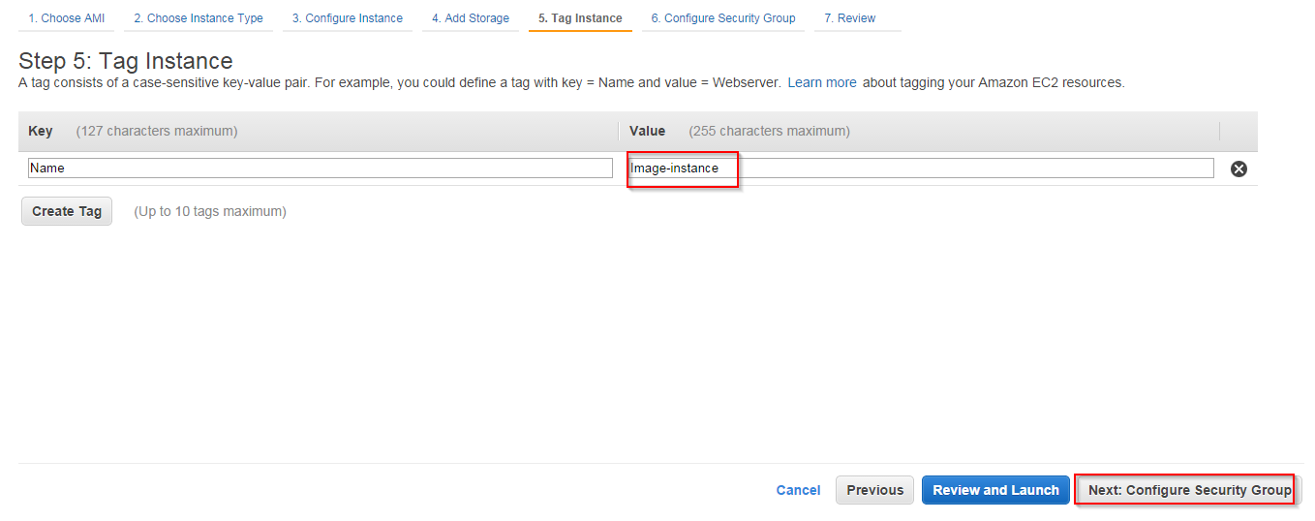

Step 10 : Select an existing security group and click on **Review and Launch** button.

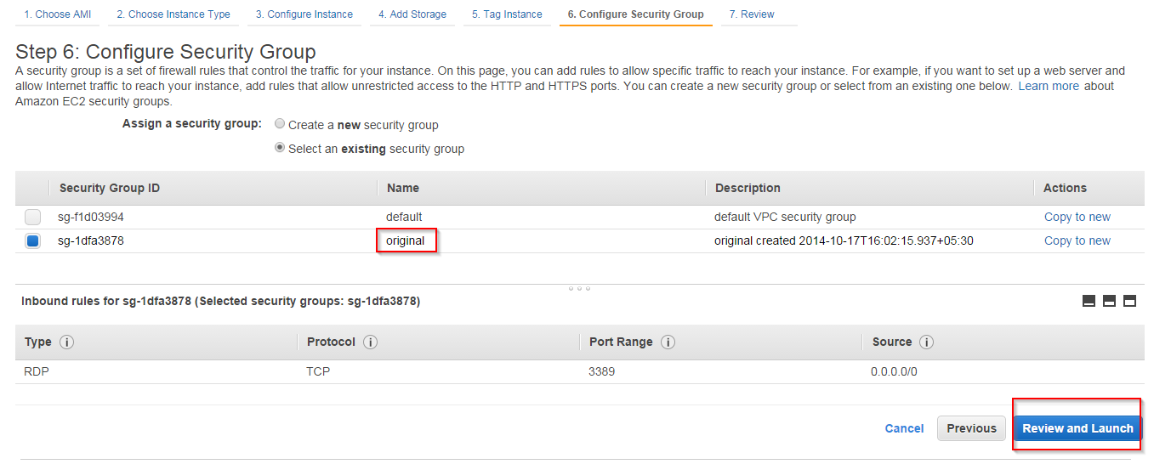

Step 11 : Click on **Launch** button.

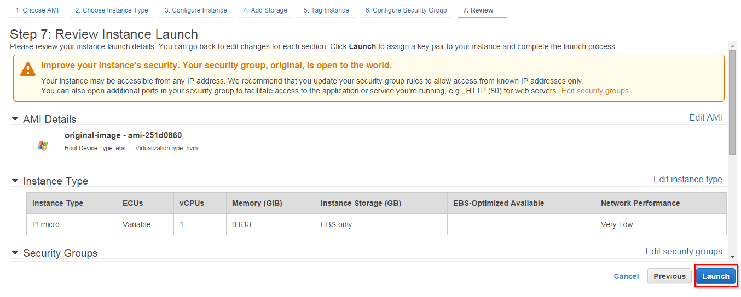

Step 12 : Select **create new key pair** from the drop down list and give a name and click on **Download key pair** button to download the key pair and click on  **Launch Instance** button.

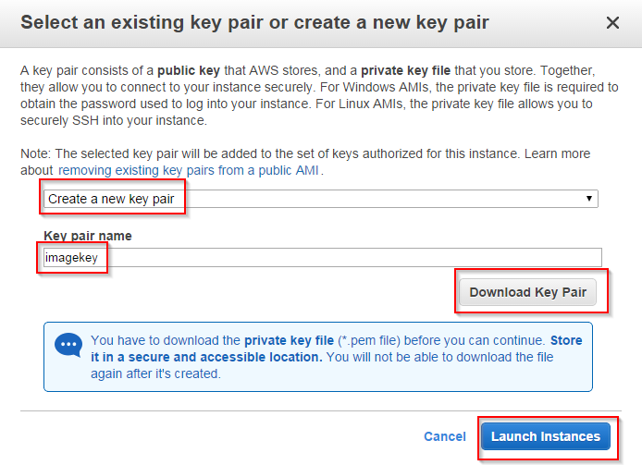

Step 13 : Click on **View Instance** button.

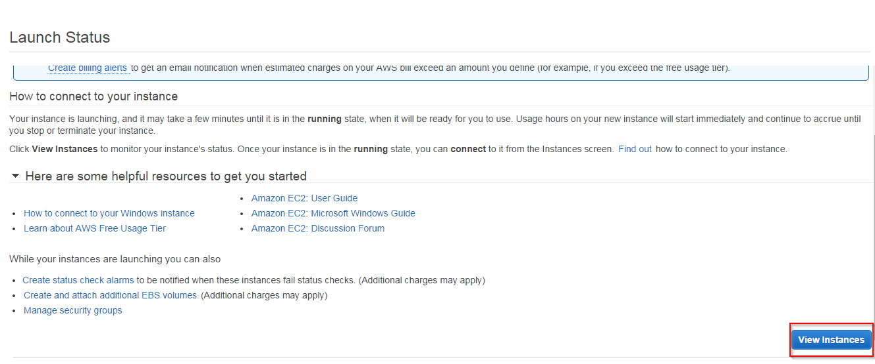

Step 14 : Now you can see one new instance is created. When it complete’s the 2/2 checks then the instance is ready to use.

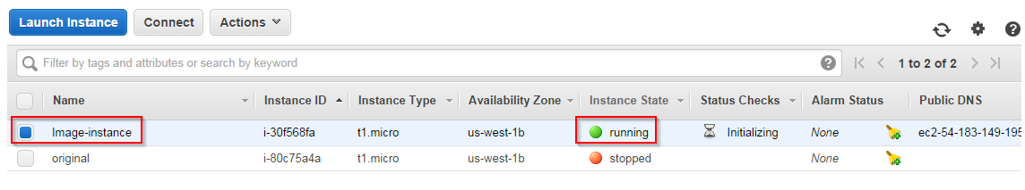

Step 15 : select the image-instance and click on **Connect** button.

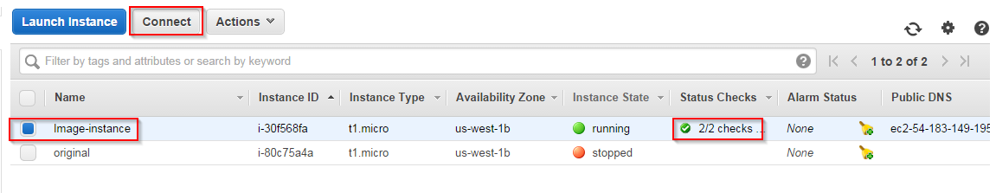

Step 16 : Click on **Get Password** button.

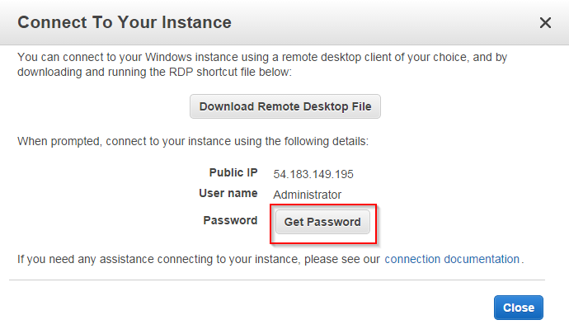

Step 17 : You will get an error message that “Password is not Available”. Click on **close** button.

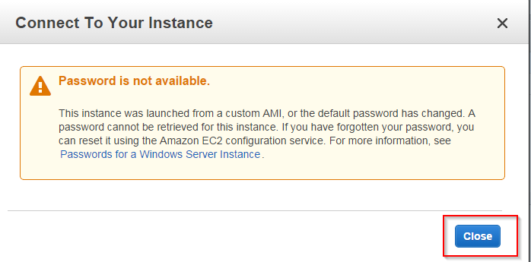

Step 18 : To retrieve the Password for the “image-instance” launch another new instance. Click on **Launch Instance** button.

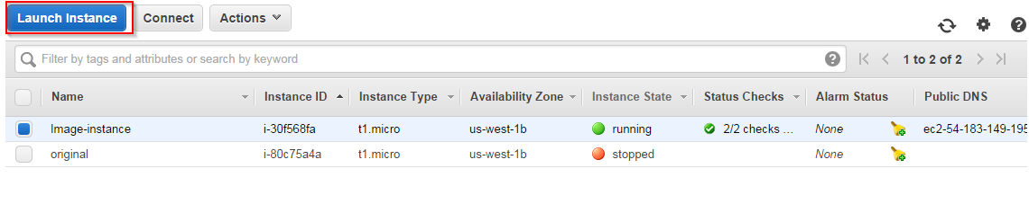

Step 19 : Select an AMI Windows 2008 R2.

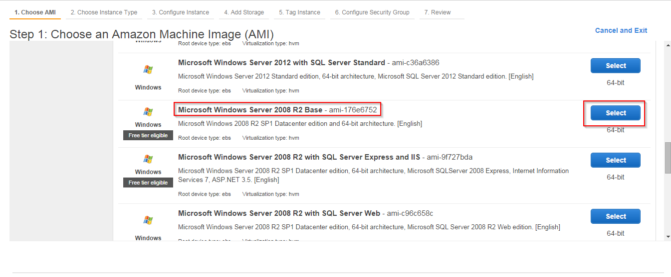

Step 20 : Select an Instance Type and click on **configure instance details** button.

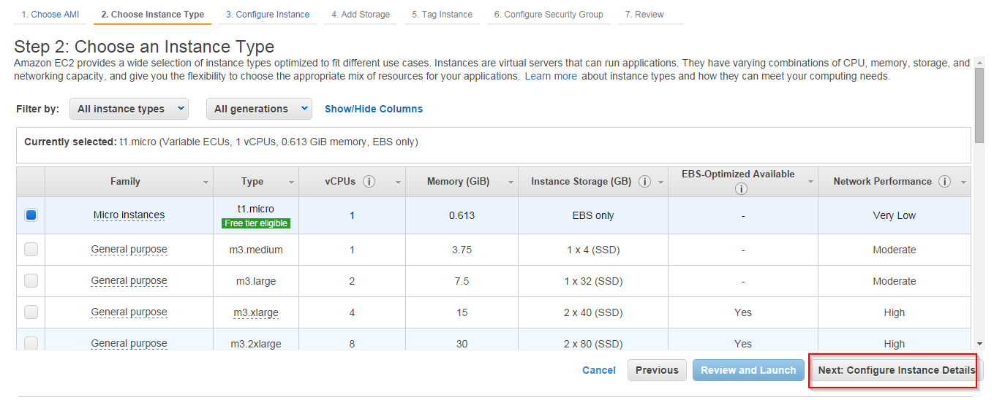

Step 21 : Click on **Add Storage** button.

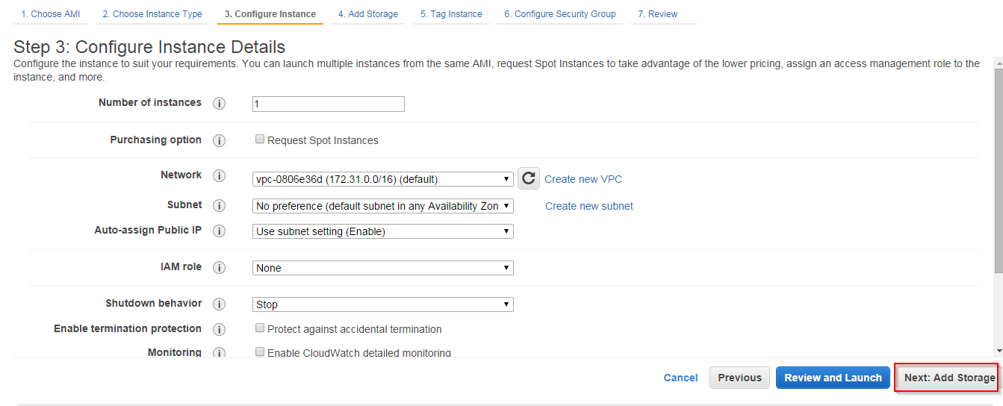

Step 22 : Click on **Tag Instance** button.

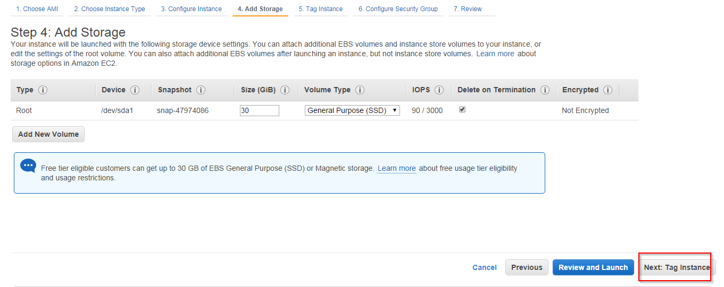

Step 23 : Give a name for the instance (ex: 2nd server) and click on **Configure Security Group** button.

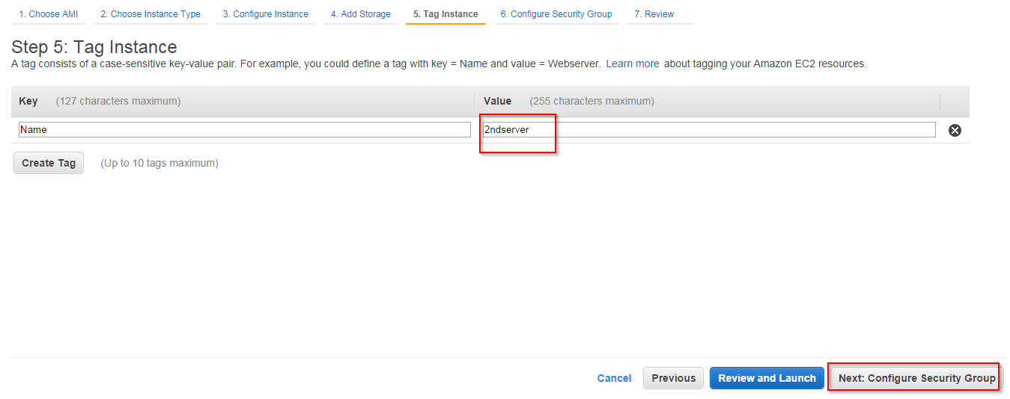

Step 24 : Select an existing security group and click on **Review and Launch** button. Then click on **Launch** button.

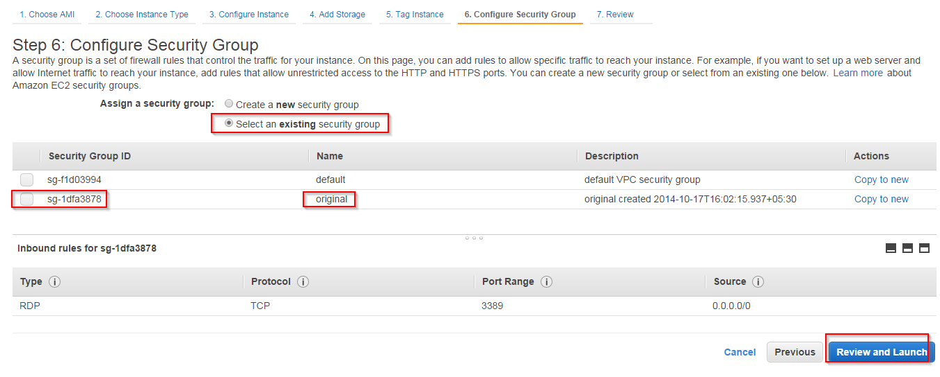

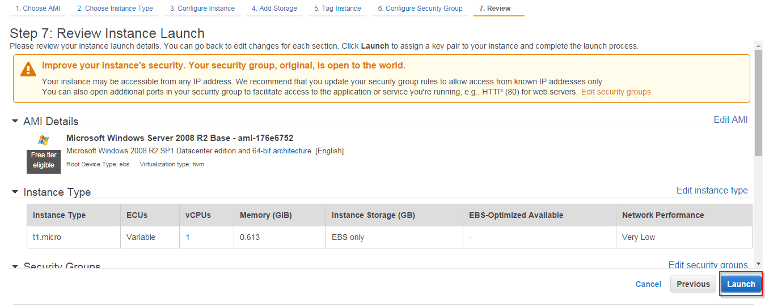

Step 25 : Select “existing key pair” option from the drop down list and select the existing key pair(image-instance key pair) and check the acknowledgement check box, click on **Launch Instance** button. Then click on **View Instance** button.

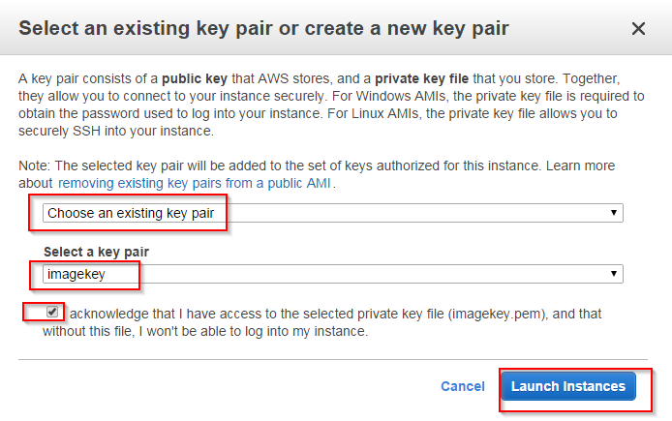 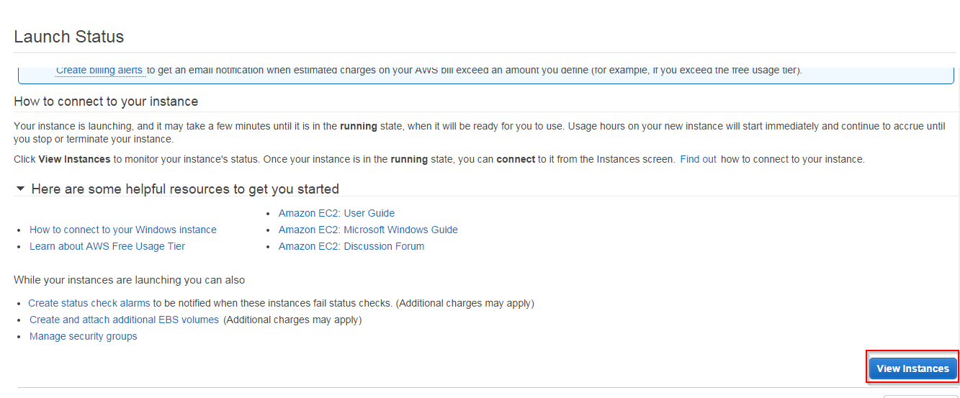

S

Step 26 : Now you can see that 2nd server is created.

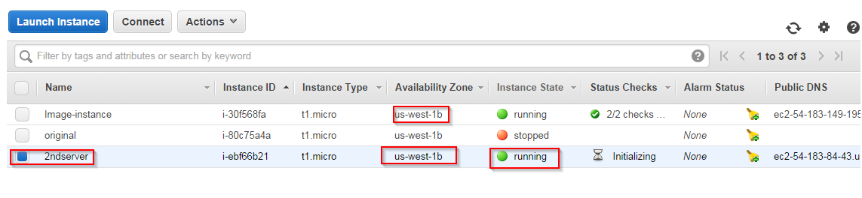

Step 27 : Select the “image-instance” and go to “description” and remember the Root device type **/dev/sda1**.

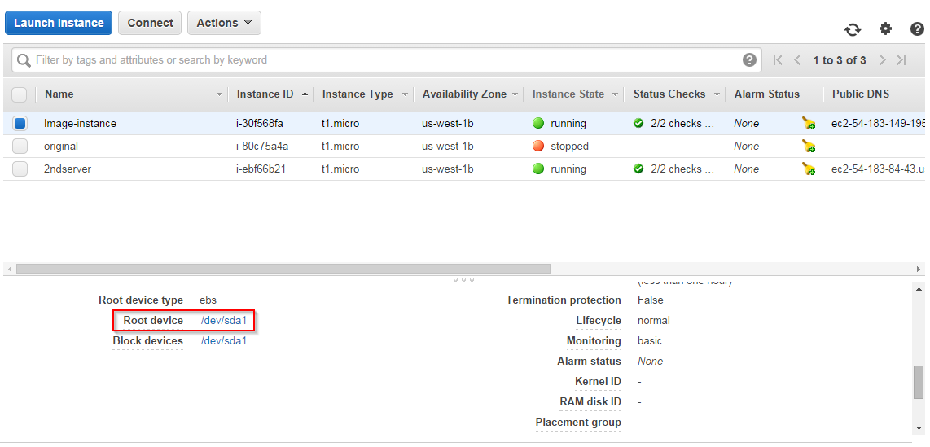

Step 28 : Select “image-instance” go to “Actions” and click on **Stop** . Then click on **Yes, Stop** button.

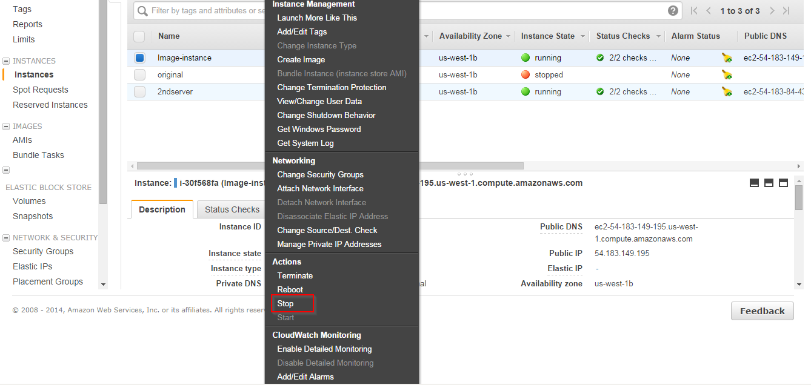

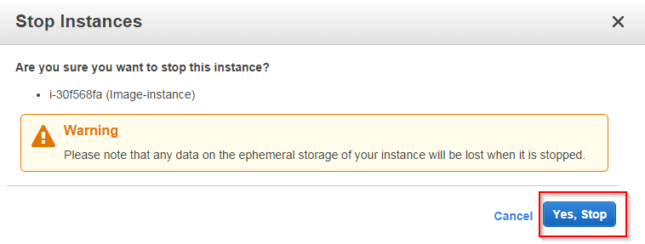

Step 29 : Now remember the “image-instance ID” and click on “Volumes” on the left panel.

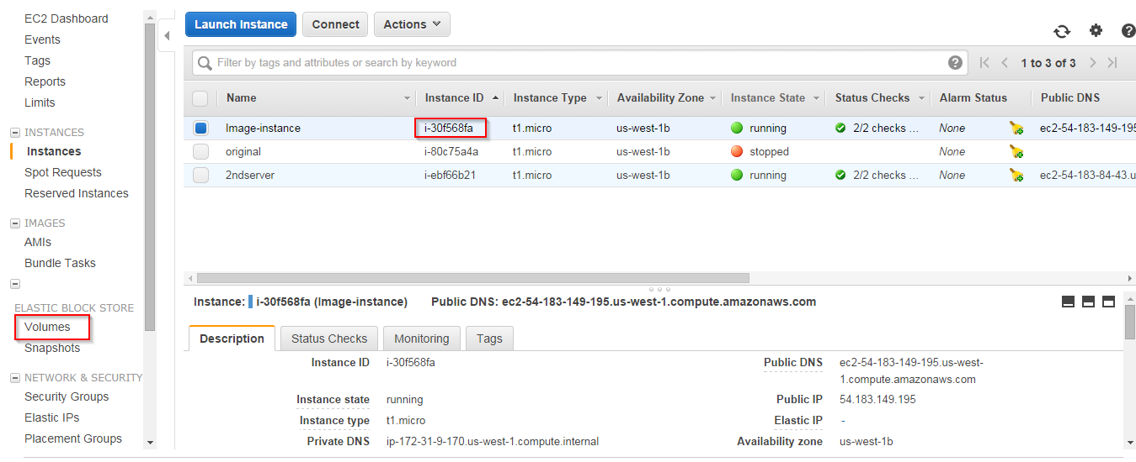

Step 30 : Find the root volume of the “image-instance” using the instance ID. Go to “Actiopns” and click on “Detach Volume”. Then click **Yes, Detach** button.

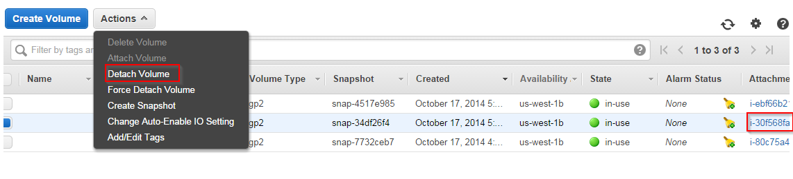

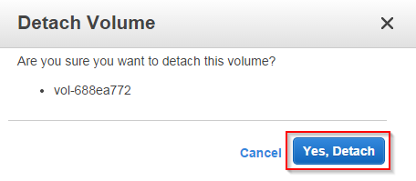

Step 31 : Now the volume state comes to “available”. Go to “Actions” and click on “Attach Volume” option.

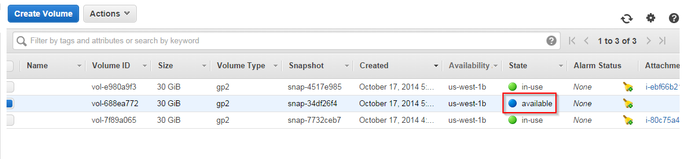 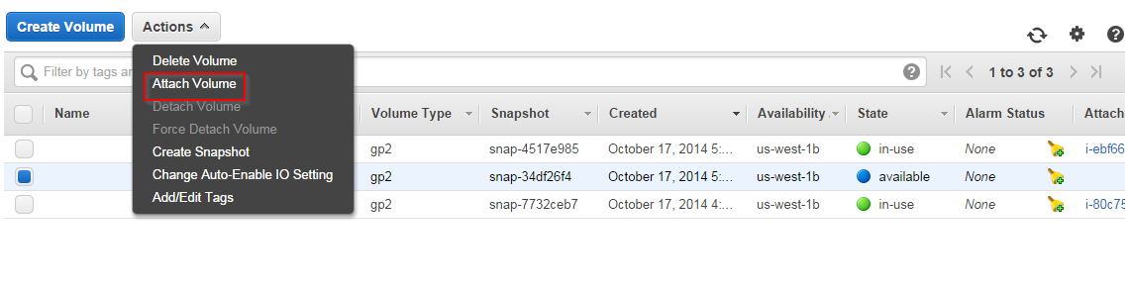

Step 32 : Select the “instance” text box and select the 2nd server(running) option. Device type should be **xvdf**. Click on **Attach** button.

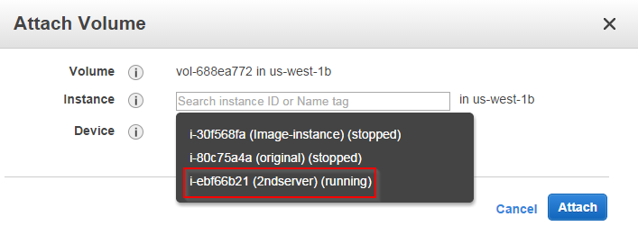

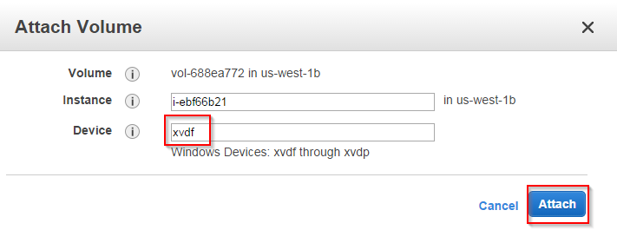

Step 33 : Go to instances and select the 2nd server and click on **connect** button. Then click on “Get Password”.

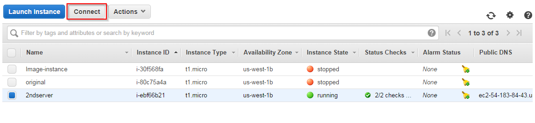

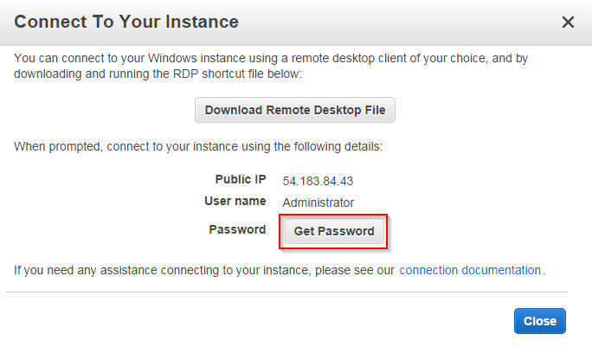

Step 34 : Click on “Choose File” and select the key pair(.pem file) and click on “Decrypt Password” . save the login credentials. Click on “Close”.

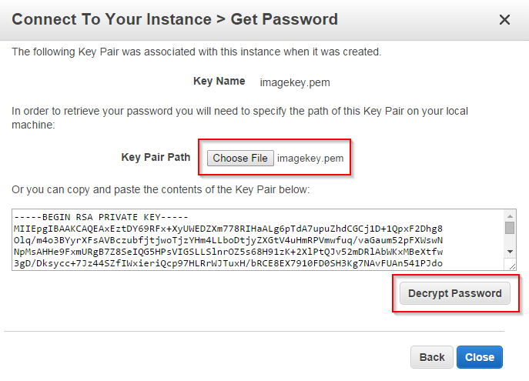

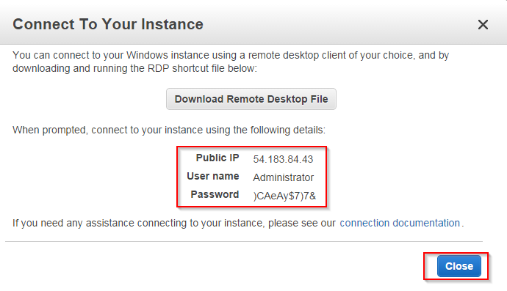

Step 35 : Open “Remote Desktop Connection” from “start” menu. Give the “2nd server IP” and “user name” and click on “connect”. Then enter the “Password”. Click on “OK”.

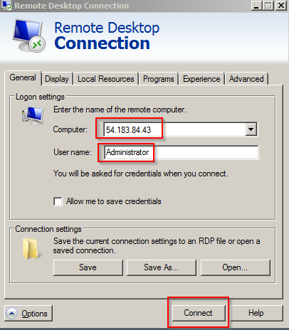

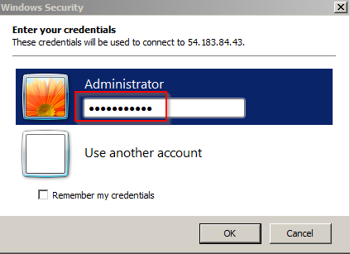

Step 36 : If you are not able to see the attached volume. Click on “server Manager->Stprage->Disk Manager”. Select the disk which is offline and Right click on the disk and click on “online”.

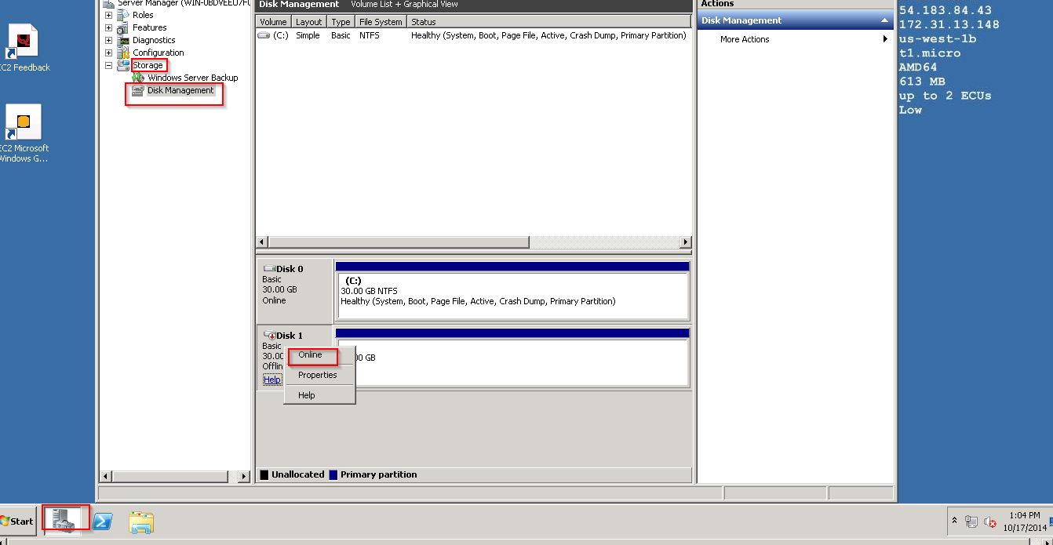

Step 37 : Now you can see the D drive.

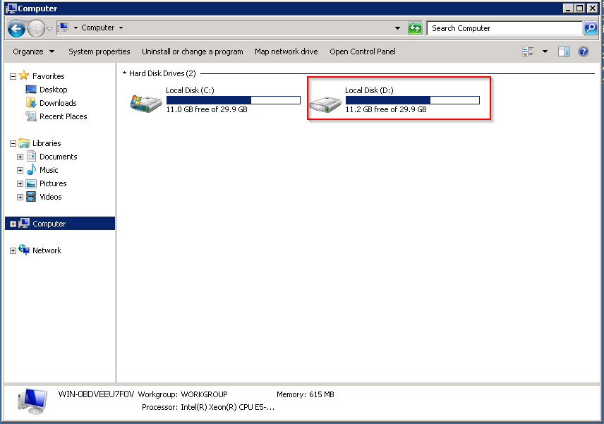

Step 38 : Modify the **config.xml** file. Go to the Path(D:\Program Files\Amazon\Ec2ConfigService\Settings\ and Modify Parameter : Ec2SetPassword from Disabled to Enabled).

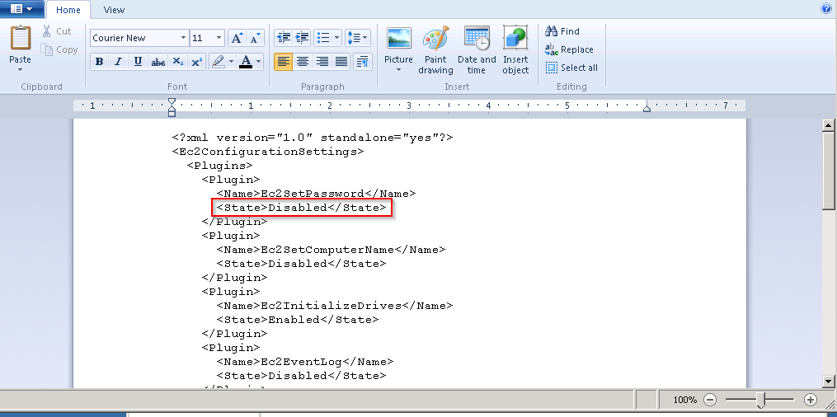

Step 39 : Download the “Bootsect.exe” file from internet and place it under(C:\Windows\System32) folder. Open “command prompt” and execute the following commands.

1. bootsect /nt60 D: /mbr
2. C:\windows\system32\bcdboot.exe D:\Windows /s D:
3. bcdedit /store D:\Boot\BCD /set {default} device partition=D:
4. bcdedit /store D:\Boot\BCD /set {default} osdevice partition=D:
5. bcdedit /store D:\Boot\BCD /set {bootmgr} device partition=D:

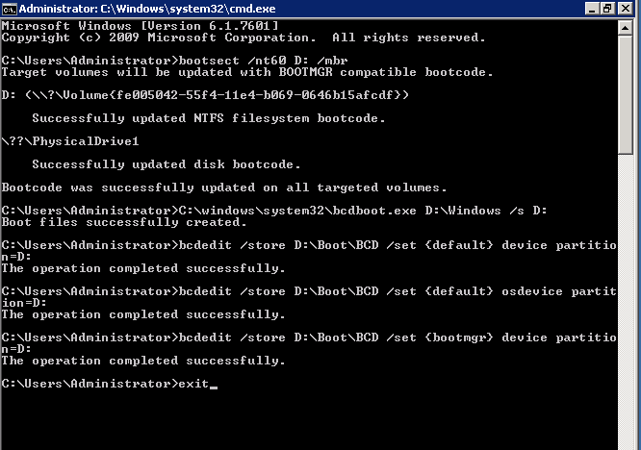

Step 40 : Go to AWS Management Console and click on “Volumes”. Select the attached volume. Go to “Actions” and click on “Detach Volume”.

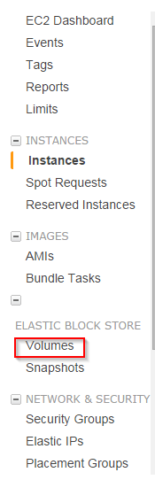

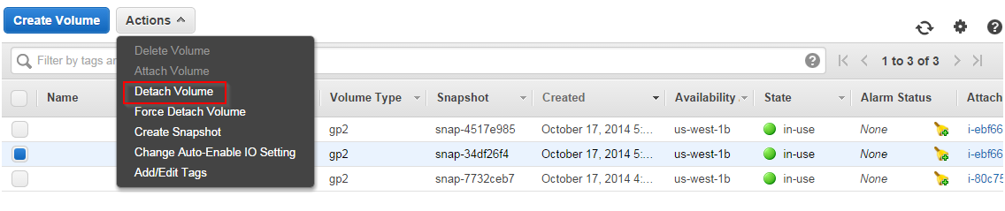

Step 41 : Click on  **Yes, Detach** button.

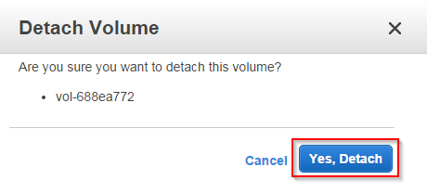

Step 42 : Select the Detached volume and go to “Actions” click on “Attach Volume”. Select the instance “image-instance”.

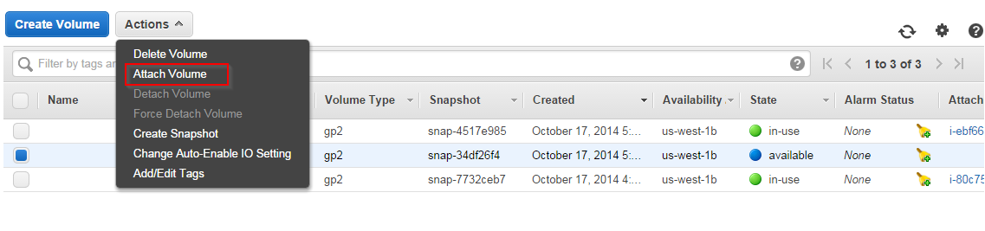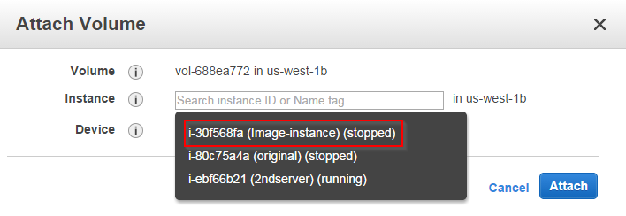

Step 43 : Device should be **/dev/sda1.** Click on “Attach”.

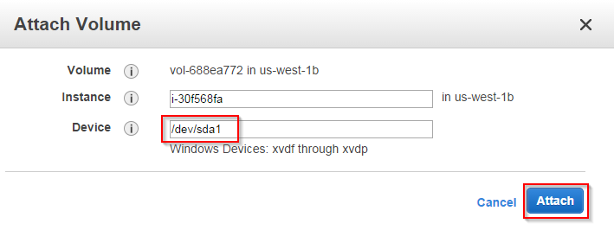

Step 43 : Click on “Instances” on left panel.

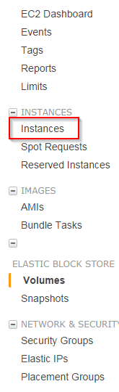

Step 44 : Select the “image-instance”. Click on “Actions” and click on “Start”. Click on “yes, start”.

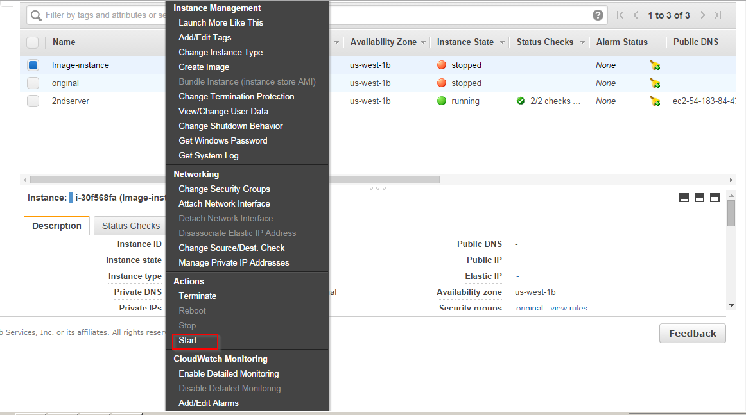

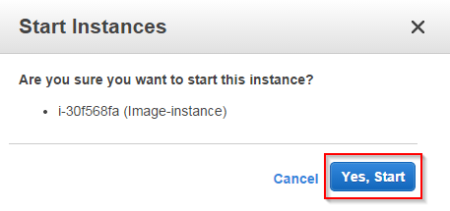

Step 45 : When it completes the “2/2 checks” click on “connect”. Then click on “Get Password”.

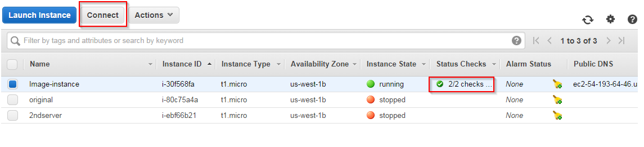

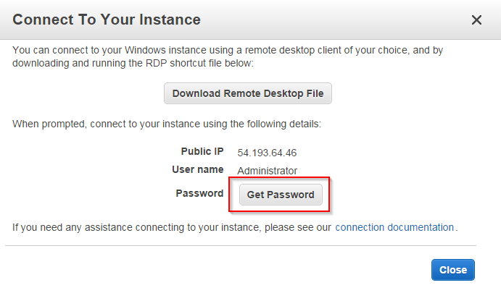

Step 46 : Click on “Choose File” and select the key pair(new .pem file). Click on “Decrypt Password”. Save the login credentials and click on “Close”.

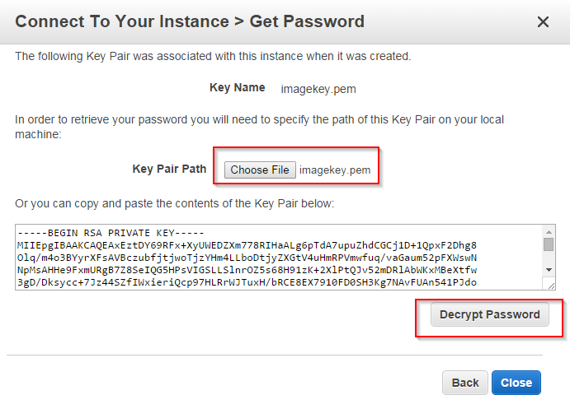

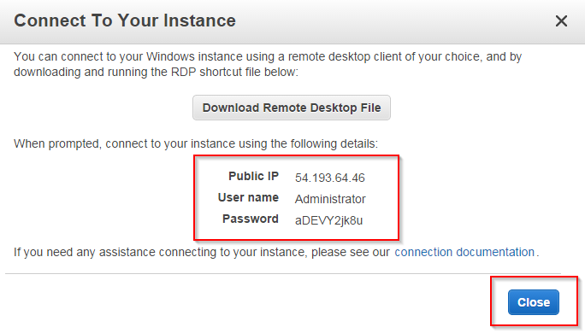

Step 47 : Open RDP Connection from start menu and give the image-instance IP and user name and click on “connect”. Then enter the “Password” and click on “OK”.

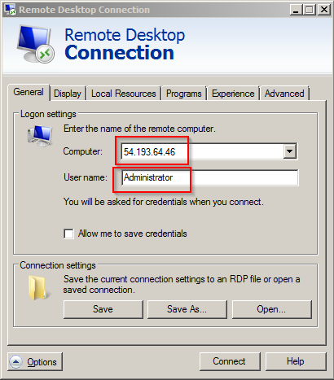

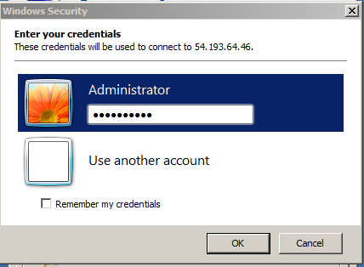

Step 48 : Now you can check your previous data.

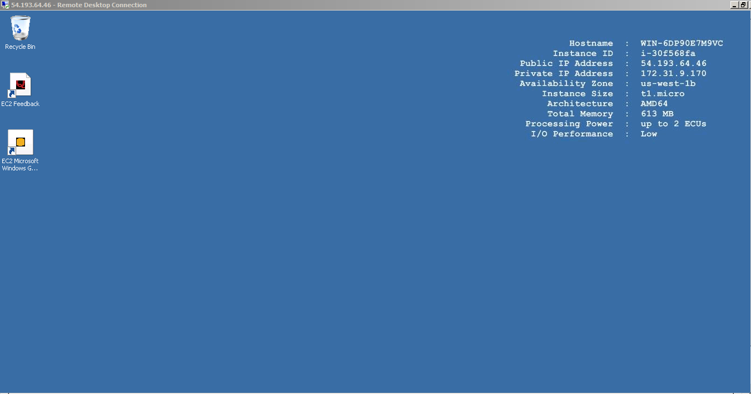

(Note : Now you can terminate the “original instance”(which you lost the key pair and password) and newly created 2nd server.)

Step 49 : Select the two instances. Go to “Actions”. Click on “Terminate”.

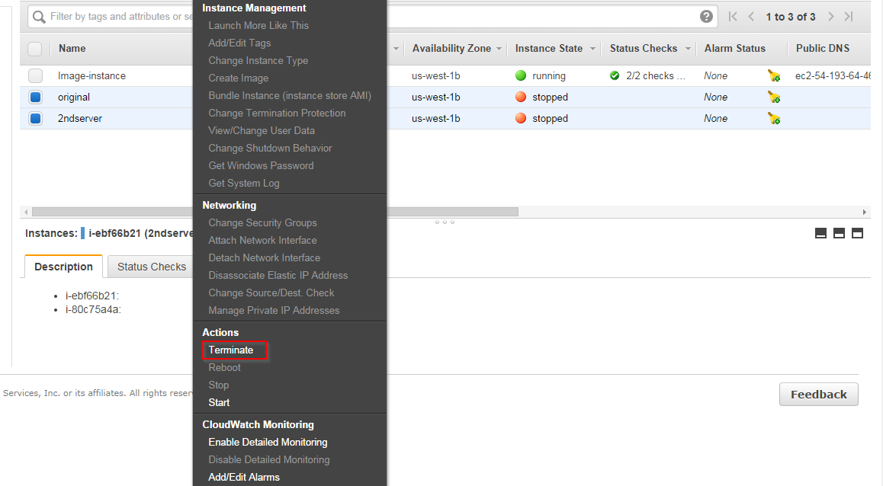

Step 50 : Click on “Yes, Terminate”.

